**Lab Assignment 3**

|  |  |
| --- | --- |
| **Roll No.: A055** | **Name: Ibrahim Shaikh** |
| **Program: B. Tech**-**CSBS (2ND YEAR)** | **Date of Release:**   2nd Aug 2021 |
| **Batch:**  A/1 | **Date of Submission:**  15th Aug 2021 |

**PROBLEM STATEMENT:**

**Problem Statement 1:** In the **“**old days” measurements used to be expresses in yards, feet and inches (12 inches = 1 foot, 3 feet = 1 yard). Show how to convert from inches into yards, feet and inches. Write a program to demonstrate the use of new and delete operators to declare the variable in this statement.

**Problem Statement 2:** Write a function to calculate average marks of the class of one subject, declare an array to read marks of the students using new operator and delete after use. Display result in main function.

**Problem Statement 3:** Write a program to calculate total volume of different measure (shapes) such as cube, sphere, cylinder and cone. Write separate functions as inline functions for each shape and return their volume to main for total calculation. Display total volume in main function.

**Problem Statement 4:** Course coordinator wants to prepare the list of students for his class by inputting data such as Name, Roll Number, Division and Program. He only input Name and Roll Number through INPUT function; other data is common for all the students. So, INPUT function will accept default arguments for constant values that need to initialize to student’s attributes. Display the data for 3 students. Write a main function to implement function with default arguments.

**Concept to be implemented**: New and delete operators (dynamic memory allocation), Inline functions and Function with default arguments

**CODE:**

**Code for Problem Statement 1**

#include<iostream>

using namespace std;

int main()

{

    int x;

    cout<<"\n1. Convert Inches to Yards\n2. Convert Inches to Feet and Inches\n";

    cout<<"\nEnter your Choice:";

    cin>>x;

    switch(x)

    {

        case 1:{

            float inches, *yard;

            cout<<"Enter the Inches: ";

            cin>>inches;

            yard = new float(0.02778*inches);      //dynamic memory allocation

            cout<<"The entered inches in yards is "<<*yard<<" yards \n";

            delete yard;

            break;

        }

        case 2:{

            float inches, *feet;

            cout<<"Enter the Inches: ";

            cin>>inches;

            feet = new float(0.08333*inches);

            cout<<"The entered inches in feet is "<<*feet<<" feets \n";

            delete feet;

            break;

        }

        default: cout<<"Wrong Input!!!";

    }

}

**Code for Problem Statement 2**

#include<iostream>

using namespace std;

int main()

{

    int n;

    float *avg, sum, m[30];

    cout<<"Enter the number of students: ";

    cin>>n;

    cout<<"Enter the marks of the students: ";

    for(int i=0;i<n;i++)                            //for loop for entering marks of n students

    {

    cin>>m[i];

    sum=sum+m[i];                               //total marks

    }

    avg = new float(sum/n);

    cout<<"The Average marks is: "<<*avg;

    delete avg;

}

**Code for Problem Statement 3**

#include <iostream>

using namespace std;

void cube()

{

    int a;

    float *vol;

    cout<<"Enter the side of the cube: ";

    cin>>a;

    vol = new float (a*a*a);

    cout<<"The Volume is: "<<*vol<<"\n";

    delete vol;

}

void cylinder()

{

    float *vol;

    int a, b;

    cout<<"Enter the radius of the cylinder: ";

    cin>>a;

    cout<<"Enter the height of the cylinder: ";

    cin>>b;

    vol = new float (22*a *a *b/7);

    cout<<"The Volume is: "<< *vol;

    delete vol;

}

void sphere()

{

    int r;

    float *vol;

    cout<<"Enter the radius of the sphere: ";

    cin>>r;

    vol = new float (4*3.14*r*r*r/3);

    cout<<"The Volume is: "<<*vol<<"\n";

    delete vol;

}

void cone()

{

    float *vol;

    int a, b;

    cout<<"Enter the radius of the cone: ";

    cin>>a;

    cout<<"Enter the height of the cone: ";

    cin>>b;

    vol = new float (22*a*a*b/21);

    cout<<"The Volume is: "<< *vol;

    delete vol;

}

int main()

{

    int opt;

    cout<<"Select the shape of which you need to find the volume\n";

    cout<<"1. CUBE\n2. SPHERE\n3. CYLINDER\n4. CONE\n ";

    cout<<"\nEnter your choice: ";

    cin>>opt;

    switch(opt)

    {

        case 1: cube();

                break;

        case 2: sphere();

                break;

        case 3: cylinder();

                break;

        case 4: cone();

                break;

        default: cout<<"\nThe entered option is INCORRECT!!!\n";

    }

    return 0;

}

**Code for Problem Statement 4**

 #include <iostream>

#include<string.h>

using namespace std;

void student(string na[30], int r, char d[2], char p[15],int no)

{

    int i;

    for(i=1;i<=no;i++)                         //for loop for multiple outputs

    {

        cout<<"\n\nThe name of Student "<<i<<" is: "<<na[i];

        cout<<"\nThe roll no. of Student "<<i<<" is: "<<r;

        cout<<"\nThe division of the Student "<<i<<" is: "<<d;

        cout<<"\nThe Program of the Student "<<i<<" is: "<<p;

    }

}

int main()

{

    string name[30];                //used string instead of char because the input is a collection of charecters

    int rn, n;

    char div[2] = "A";

    char prog[15] = "BTech. CSBS";

    cout<<"Enter the number of students: ";

    cin>>n;

    for(int i=1;i<=n;i++)

    {

        cout<<"\n\nEnter the name of student "<<i<<": ";

        cin>>name[i];              //was facing an error here when it was char

        cout<<"Enter the roll number of student "<<i<<": ";

        cin>>rn;

    }

    cout<<"Details saved!!!";

    student(name, rn, div, prog, n);

}

**OUTPUT:**

**1.**

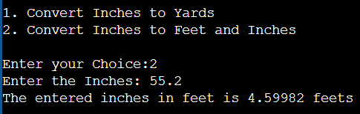

**2.**

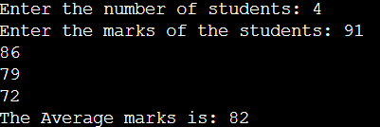

**3.**

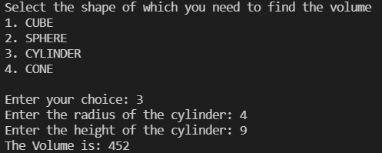

**4.**

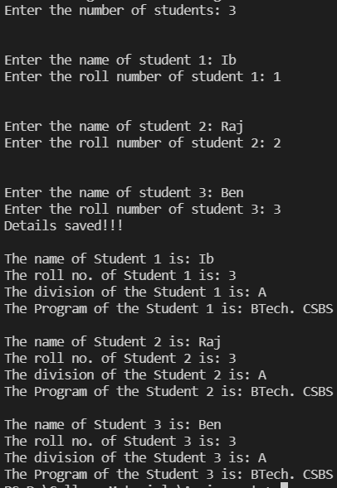

**LINK FOR THE CODE:** Done with VSCode